[Edupeer MVP]

## **Resources to help:**

[Survey data report](https://drive.google.com/file/d/1rzXXAellBu03hYdsRZM_6ajlUMfgq60i/view?usp=sharing)

[Brand identity document](https://drive.google.com/file/d/1MUEsoRrLcdEaH32XleXdjvq1tGEOy2OD/view?usp=sharing)

Brand identity guidelines

[Last presentation document:](https://www.canva.com/design/DAGr-YzNj9w/IbdO7UaPUI4NB2O_0N9Tww/edit?utm_content=DAGr-YzNj9w&utm_campaign=designshare&utm_medium=link2&utm_source=sharebutton)

[User stories draft](https://docs.google.com/document/d/1gotVOE14xu6Q3f_dNjSzYqHN-Z2GJWhg8Ye_zZon29E/edit?usp=sharing)

[Product backlog](https://docs.google.com/document/d/122qKhSw_uLIy1sed1lESdh-nRa-YaRr95FJ-ELY8XhY/edit?usp=sharing)

[Althub framework](https://docs.google.com/presentation/d/1VBGAqfG3KIyv5dOJhww8Rf8YG9vnA7uqMYEwQj-dofY/edit?usp=sharing)

[Team role guidebook](https://docs.google.com/document/d/1S-Md6G5yCZZ3LJq8SCi-FiztVilWJ9FJwYP-D97RBeg/edit?usp=sharing)

Business model and pricing:

[Working Survey questionnaire document (to find our research goals)](https://docs.google.com/document/d/1sgPgqInwYWw4ZlHtkt3D5UkTqZMhorP3_bFfLQAJbo8/edit?usp=sharing)

# Last Updated: Jul 15, 2025

# Change Log

* 15/07/2025 - Initial version

# **Overview**

| Purpose *Edupeerhub is a peer-powered ed-tech platform built to democratize access to quality education through a network of learners and mentors.* | Audience *We have two primary audiences:* ***students in*** *SS2 and SS3 in Nigeria (aged 15-18) who are actively preparing for the WAEC, NECO, and JAMB exams. They are digital natives, but they face constraints such as limited internet data and device quality.*  ***Tutors:*** *University undergraduates and recent graduates serving in the NYSC programs (ages 19-25). They are subject matter experts driven by altruism, skill-building and professional recognition.* |
| --- | --- |
| What *We are building a minimum viable product focused strictly on one core feature: a platform that allows students to find, schedule, and participate in live 1-on-1 video tutoring sessions with vetted peer tutors. (Abisoye’s document outlines this)* | Why *Many secondary school students struggle with inconsistent access to quality academic support due to several challenges, including limited teacher availability, uneven access to learning materials and limited access to personalised learning within and outside the regular school environment.* |
| How *We want a simple, mobile-first web application where students can browse tutor profiles, based on subject expertise, request a session at a convenient time, and connect via a live video interface with basic chat and whiteboard functionality.* | When *The development and coding phase of the MVP is scheduled to take pace from Friday, 11 2025 and end on Wednesday, August 20, 2025.* |
|  |  |

# **MVP Goals and Success Criteria**

*We will measure the success of our MVP by tracking these three Key Performance Indicators (KPIs).*

***KPI 1: Session Completion Rate***

* *Description: The percentage of scheduled sessions that are successfully completed by both student and tutor.*
* *Target: Achieve an 85% completion rate during our pilot launch.*

***KPI 2: Student Activation Rate***

* *Description: The percentage of new students who sign up and complete at least one tutoring session within their first 7 days.*
* *Target: 60% of new students are activated within their first week.*

***KPI 3: Post-Session Satisfaction Score***

* *Description: The average rating students give on a scale of 1-5 immediately after a session ends, answering "How helpful was this session?"*
* *Target: Maintain an average satisfaction score of 4.0/5.0 or higher.*

# **Assumptions and Knowledge**

**Knowledge (What We KNOW from Data)**

* *Knowledge 1: Students need the most help in core science subjects. Our survey of 129 students confirmed that Mathematics, Physics, and Chemistry are their top 3 most challenging subjects.*
* *Knowledge 2: Our core feature is highly desired. Our research shows that "1-on-1 live tutoring" was the #1 most-requested feature by both students and tutors, validating our MVP's sharp focus.*
* *Knowledge 3: There is strong user demand for our platform. Our data indicates that nearly 80% of students are 'Likely' or 'Very Likely' to use a free peer-tutoring platform like Edupeerhub.*
* *Knowledge 4: We know how to motivate our tutors. Our survey of 111 tutors shows they are primarily driven by "giving back to the community" (47.8%) and that official recognition is a key incentive for retention.*

**Assumptions (What We BELIEVE to be True)**

* *Assumption 1: We assume that our volunteer tutors, motivated by altruism and the promise of certificates, will be consistently available and reliable enough to meet student demand during our pilot phase.*
* *Assumption 2: We assume that a simple in-app rating and reporting system will be sufficient to maintain quality control and ensure a safe user environment for the MVP.*
* *Assumption 3: We assume that our initial target schools and NYSC groups will be willing to partner with us for the pilot launch based on our value proposition alone, without needing prior operational proof.*

# **Business Models and Pricing**

XXXX   
XXXX

How will this initiative be priced? Part of standard pricing plans? An extension, or add-on? A whole new business model?

# **Milestones**

*[your text here: list the different tasks that are needed to be done, you can also use the Gantt chart to define timeframes if you’d like or delete it]*

* Task 1
* Task 2
* *[For example, Design low-level design for UX purposes]*
* *[Prototype Testing]*
* *[And so on…] to edit the table - just make a copy of it and paste it here!*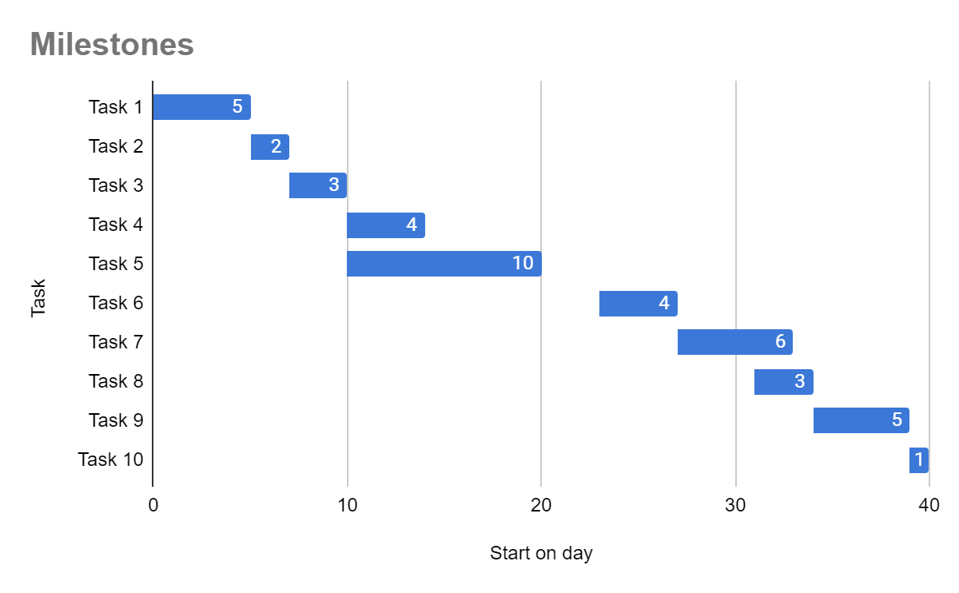

# **Data Requirements**

*[ What data should your product/feature collect from users and in what format, if you don't know what formats are possible and how does it work - consult with your developers and data analysts, but whatever you decide - you must collect data!]*

While using the feature, collect the following data:

1. Data point 1
2. Data point 2
3. Data point 3

# **Interaction & Design**

## User/Task Flows

*[Use user flows to explain your product behavior (you can use other symbols and methods as long as it is understood easily), this is a basic structure for the doc but you can do it in a separate file using one of the dedicated tools:* [*Draw.io*](https://www.draw.io/)*,* [*Flowmapp*](https://flowmapp.com/)*,* [*Google Drawings*](https://docs.google.com/drawings/) *or read more about task flow* [*here*](https://uxmisfit.com/2020/08/17/what-is-a-user-flow-everything-you-need-to-know/)*]*







## 

## 

## **User Stories & Feature Requirements**

*[your text here: What does the product/feature generally do, if you want you can use some user stories here to help and explain the usage of the product] Focus on user needs and outcomes.*

== Link to the user stories: https://docs.google.com/document/d/1gotVOE14xu6Q3f_dNjSzYqHN-Z2GJWhg8Ye_zZon29E/edit?usp=sharing

=== Link to the product backlog draft and features requirements: <https://docs.google.com/document/d/122qKhSw_uLIy1sed1lESdh-nRa-YaRr95FJ-ELY8XhY/edit?usp=sharing>

## 

## **Product Marketing and Communication**

## Key metrics

How do you measure success and adoption for the product initiative? List concrete metrics to track here.

## Terms, wording, and copy

The key words and terms to use in/for the product. Links to additional materials.

# Personas

Customer or user personas.

## **Mockups for Each Feature page to guide designers**

=== (Look at the features document (product backlog list), and find inspiration on Figma, Canva and Google generally. This would serve as our low-fidelity wireframes.

## Design/Wireframes/UI Design

*[Use wireframes to show the developers what they are actually building - if you have a UX designer in your team, ask them to do it properly with you, they will need to complete the UI for the project later anyway. For most people, using* [*Figma*](https://www.figma.com/wireframe-tool/) *is a great way to build wireframes but you can also use other tools such as* [*Balsamiq*](https://balsamiq.com/)*,* [*Mockflow*](https://www.mockflow.com/)*, and more]*

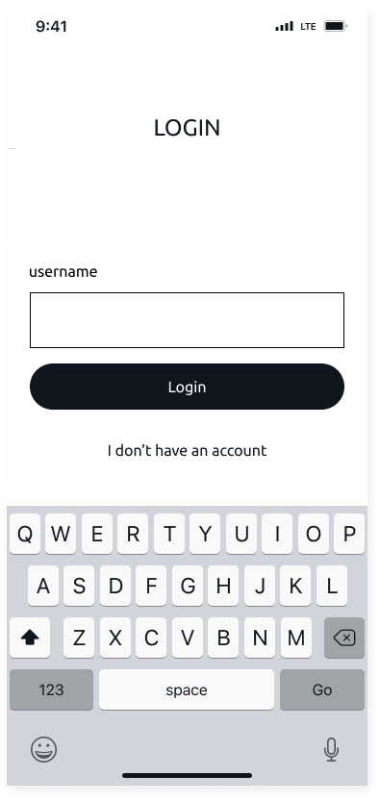



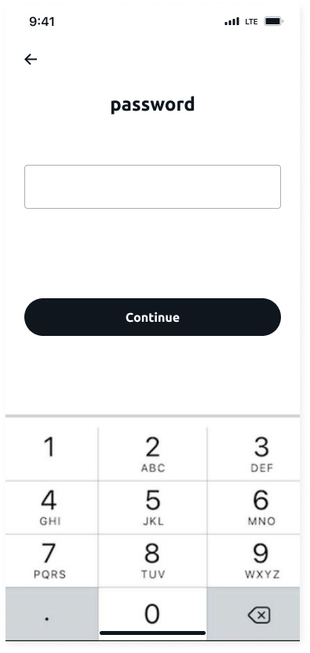

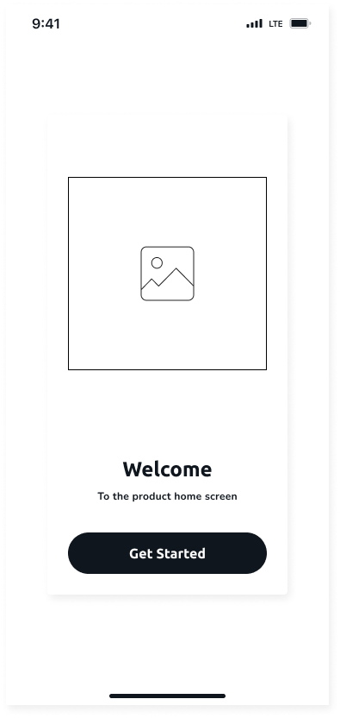



# **Technical and Infrastructure Specifications**

The Backend, Frontend, and Cloud Engineering leads discuss the technical architecture needed to support the user flow.

**Your Role (PM):** Facilitate the discussion to identify dependencies (e.g., "Frontend needs the user login API from Backend before they can build the dashboard").

If it can fit here, that’s okay; if not, please outline it on this empty page [linked here.](https://docs.google.com/document/d/1zr7xN_dXiswg3cOIKlXQeoaDnhUeOTTBTfww4Tuqvfc/edit?usp=sharing)

# **CyberSecurity Specifications**

Anything relevant for/from backend engineering. Such as key technical challenges or risks.

If it can fit here, that’s okay; if not, please outline it on this empty page [linked here.](https://docs.google.com/document/d/1zr7xN_dXiswg3cOIKlXQeoaDnhUeOTTBTfww4Tuqvfc/edit?usp=sharing)

# **Out of scope - Future Plans**

*[Define what is out of scope for this project - Scope is a way to set boundaries on your project ]*

# **Non Functional Requirements**

*[Define obscure easy to miss requirements, ask the developers and backend team for this ]*

# **Questions?**

*[This is the place to answer your team’s questions about the PRD or the product/feature themselves and document it so everybody will have the access to it ]*

| *Question 1* |  |
| --- | --- |
| *Question 2* |  |
| *Question 3* |  |
| *Question 4* |  |

## Overview

This document outlines the cybersecurity specifications necessary for building a secure, reliable, and compliant MVP of EdupeerHub — a peer-powered ed-tech platform focused on delivering personalized, live, 1-on-1 tutoring experiences to secondary school students in Nigeria. Given the sensitivity of working with minors and academic records, cybersecurity is a non-negotiable layer in the platform’s architecture.

## 1. User Authentication and Access Control

Objective: Prevent unauthorized access and ensure each user can only access permitted resources based on their role.

- Strong Password Enforcement: Enforce minimum complexity (at least 8 characters, mixed case, symbols).

- Multi-Factor Authentication (MFA): Required for tutors and admin accounts.

- Role-Based Access Control (RBAC):

- Students: Access to personal dashboard and scheduled sessions.

- Tutors: Access to tutor dashboard and assigned sessions only.

- Admins: Broader access with audit trails and logging.

## 2. Data Privacy and Protection

Objective: Protect personally identifiable information (PII), especially that of minors.

- Encryption:

- In-Transit: All data transmissions must use HTTPS (TLS 1.2 or higher).

- At-Rest: Encrypt sensitive data fields such as user profiles and session records.

- Data Minimization: Only collect essential data as defined in the product’s data requirements section.

- Regulatory Compliance:

- Ensure compliance with Nigeria Data Protection Regulation (NDPR).

- Prepare for GDPR-level compliance in future scalability scenarios.

## 3. Secure Video & Communication Features

Objective: Secure real-time communication between students and tutors.

- End-to-End Encryption (E2EE): Required for video sessions and in-app chat systems.

- Session Metadata Logging: Log session start/end times, participants, and IP addresses for security monitoring.

- Abuse Reporting System:

- Allow students and tutors to report harassment, misconduct, or inappropriate behavior.

- Integrate reports into moderation/admin review workflows.

## 4. Application Security

Objective: Protect the application from common vulnerabilities and attacks.

- Secure Coding Standards: Follow OWASP Top 10 guidelines in development.

- Input Validation & Sanitization: Especially on login forms, chat input, and profile details.

- Rate Limiting & CAPTCHA: Implement on login and password reset endpoints to deter brute force attempts.

## 5. Monitoring and Incident Response

Objective: Ensure real-time threat detection and have procedures to respond to breaches or vulnerabilities.

- Security Logging and Monitoring: Track failed/successful logins, data access attempts, and unusual session behavior.

- SIEM Integration (Lightweight for MVP): Use open-source or cost-effective tools to aggregate logs.

- Incident Response Playbook: Prepare a documented plan for:

- Account compromise

- Platform misuse

- Data breach scenarios

## 6. Compliance and Legal Safeguards

Objective: Reduce legal risk and protect underage users.

- Parental Consent: Required for minors under 18 to use the platform.

- Privacy Policy & Terms of Use: Must be visible during sign-up and easily accessible at all times.

- Tutor Vetting: Verification and background checks to ensure tutor eligibility and professionalism.

## Suggested Tools & Technologies

| Area | Suggested Tool |

|-----------------------|----------------------------------|

| Authentication & MFA | Firebase Authentication / Auth0 |

| Video Communication | Jitsi Meet / Twilio (E2EE) |

| Security Testing | OWASP ZAP / Burp Suite |

| Logging & Monitoring | ELK Stack / Wazuh / OpenSearch |

## Future Security Enhancements (Beyond MVP)

- Session recording with secure cloud storage (optional, pending compliance).

- AI-assisted behavior monitoring during sessions.

- Secure document sharing between tutors and students.